**Scenario-1**

**Code -**

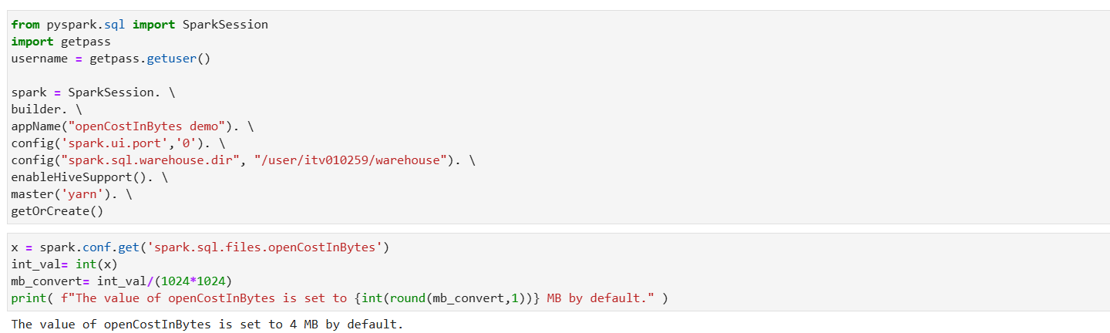

**Scenario-2**

**Code-**

